**DAILY ONLINE ACTIVITIES SUMMARY**

|  |  |  |  |  |  |  |  |  |
| --- | --- | --- | --- | --- | --- | --- | --- | --- |
| **Date:** | 28/06/2020 | | | | | **Name:** | SHREEKIRAN R BHAT | |
| **Sem & Sec** | IV sem & B section | | | | | **USN:** | 4AL18CS080 | |
| **Online Test Summary** | | | | | | | | |
| **Subject** | | - | | | | | | |
| **Max. Marks** | | 30 | | **Score** | | | - | |
| **Certification Course Summary** | | | | | | | | |
| **Course** | Blockchain Basics | | | | | | | |
| **Certificate Provider** | | | Greatlearning academy | | **Duration** | | | 2.5hours |
| **Coding Challenges** | | | | | | | | |
| **Problem Statement1:**  NOT GIVEN | | | | | | | | |
| **Status**: Executed | | | | | | | | |
| **Uploaded the report in Github** | | | | | YES | | | |
| **If yes Repository name** | | | | | lockdown-coding | | | |
| **Uploaded the report in slack** | | | | | YES | | | |

**Online Test Summary:** Test was not conducted.

**Online Certification Course Summary:** In today’s session I have learnt about blockchain Ecosystem.

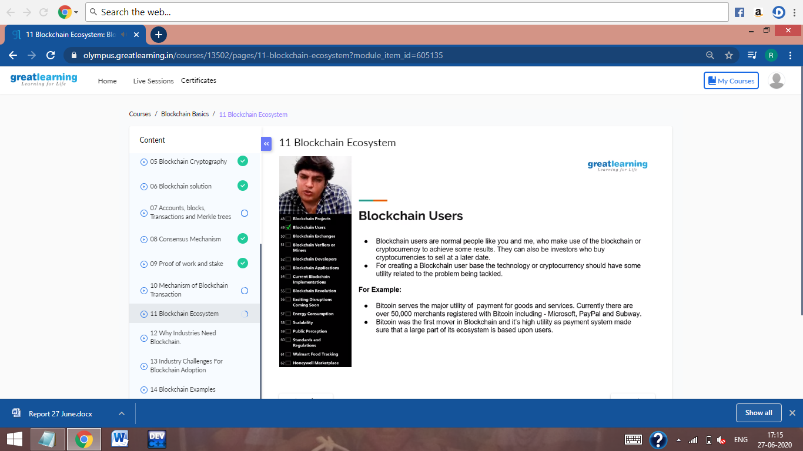

This is the snap shot of today’s session.

**Online Coding Summary:** was not given.